**BANK LOAN ANALYSIS QUERY DOCUMENT**

**BANK LOAN DATA OVERVIEW**

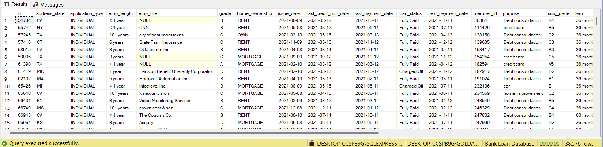

**TOTAL NUMBER OF LOAN APPLICATIONS**



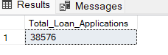

**MONTH TO DATE (MTD) LOAN APPLICATIONS**





**PREVIOUS MONTH TO DATE (PMTD) LOAN APPLICATIONS**

|  |
| --- |
| **MONTH OVER MONTH (MOM) CALCULATION FORMULA**  **MOM = (MTD-PMTD) PMTD** |



**TOTAL LOAN DISBURSED**





**MTD TOTAL LOAN DISBURSED**



**PMTD TOTAL LOAN DISBURSED**



**TOTAL REPAYMENTS COLLECTED**



**MTD TOTAL REPAYMENTS COLLECTED**



**PMTD TOTAL REPAYMENTS COLLECTED**



**AVERAGE INTEREST RATE**



**AVERAGE INTEREST RATE (%)**



**AVERAGE INTEREST RATE (%) – rounded (4 decimal places before %)**



**MTD Average Interest**



**PMTD Average Interest**



**Average Debt-to-Income-Ratio (DTI)**



**MTD Average DTI**



**PMTD Average DTI**



**GOOD LOAN ISSUED**

**Good Loan Percentage**

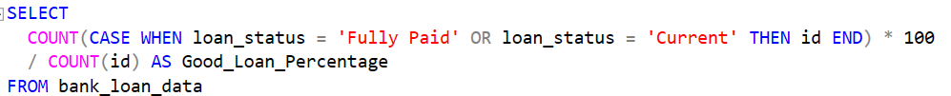

**Good Loan Applications**

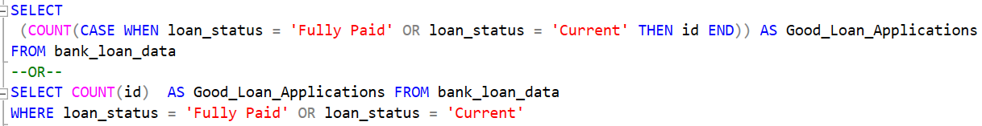



**Good Loan Disbursed**



**Good Loan Repayments Collected**



**BAD LOAN ISSUED**

**Bad Loan Percentage**

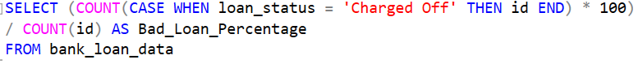

**Bad Loan Applications**

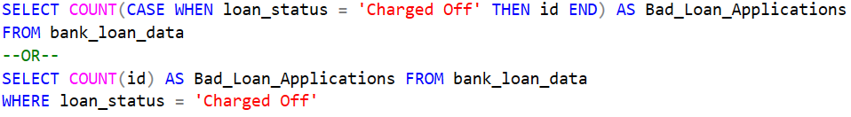

**Bad Loan Disbursed**



**Bad Loan Repayments Collected**



**LOAN STATUS**

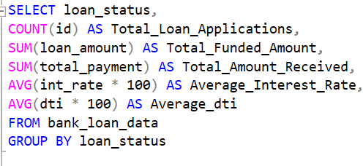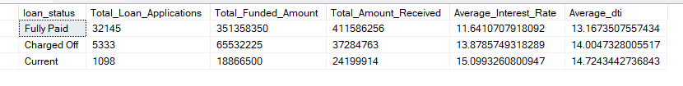

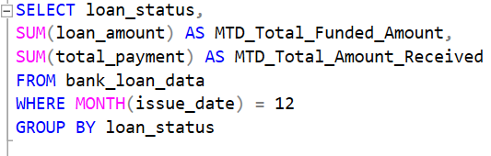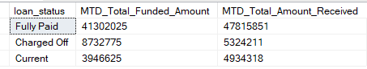

**BANK LOAN REPORT**

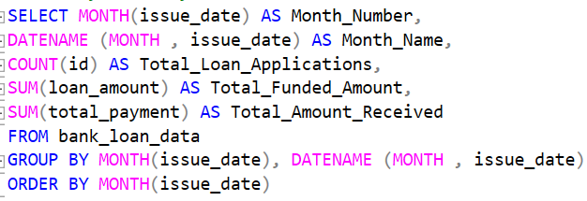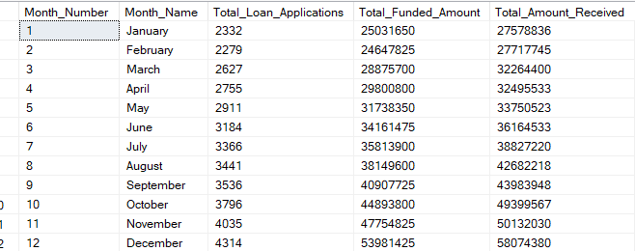

**STATE**

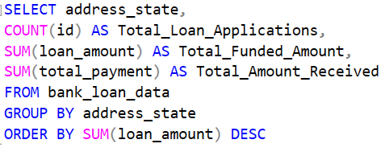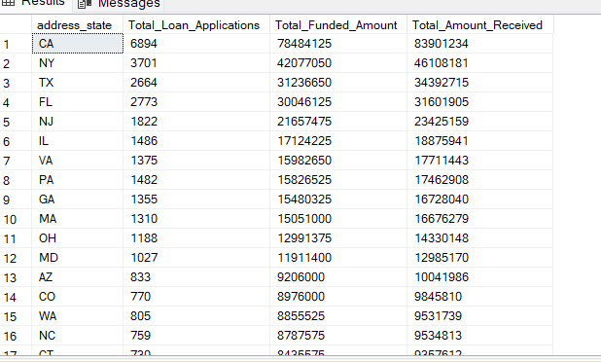

**TERM**

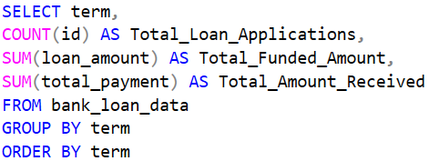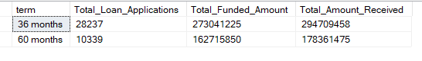

**EMPLOYEE LENGTH**

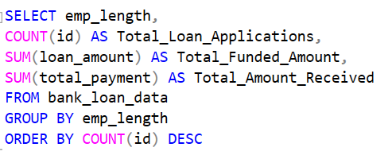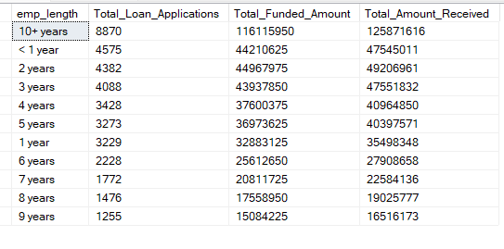

**PURPOSE**

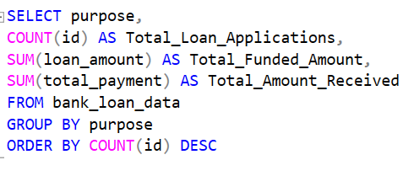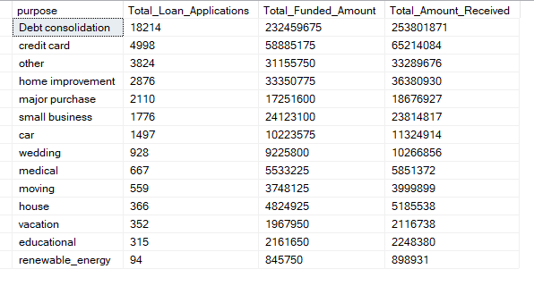

**HOME OWNERSHIP**

